**CONTENT**

**Contents**

**1.INTRODUCTION 1**

**1.1 Problem Statement 3**

**1.2 Objective of The Project 4**

**2. LITERATURE REVIEW 5**

**2.1. Review of the papers 5**

**2.2 Discussion on Research Papers 11**

**2.3 Research Gap 16**

**3 SYSTEM DESIGN 17**

**3.1 Component or Work Piece 17**

**3.2 Procedure 18**

**3.3 Components of Fixture 19**

**3.4 CAD Modelling 20**

**4. SYSTEM MANUFACTURING 22**

**4 Components and their specification 22**

**5 EXPERIMENTAL VALIDATION 27**

**5.1 Experimental Testing and Observation 27**

**5.2 Calculation 28**

**6 GRAPHS AND RESULTS 29**

**6.1 Graphical Comparison 29**

**6.2 Result 32**

**7 SUMMARY 33**

**8 CONCLUDING REMARKS 34**

**8.1 Conclusion 34**

**8.2 Future Scope 35**

**REFERENCES 38**

# 1.INTRODUCTION

In this project, we have to deal with the design and manufacturing of fixture of K4 frame of NS200 Bajaj Pulsar. The project is provided by BADVE Engineering Ltd., this company manufactures auto-motive parts for two-wheelers. The company has various areas of work line such as K4 line, K8 line, K15 line, etc. For our project, our work area was K4 line. In this line, grinding is done on stamp and welded with head pipe on stations 120A and 120B. The welding process done was MIG welding. Due to the improper grinding at K4 line, the welding was being improperly done by the robotic arm at stations 120A and 120B.

At stations 120A and 120B the robotic arms are fed with programs to work accordingly. These arms weld around the curved profile of the grounded portion and leave burn-holes at that portion. These burn-holes effect on strength of the stamp and conclude in fracture of the chassis in the long run. To fix the problem we came up with an idea to design a fixture for almost proper grinding.

Fixture is a work piece-locating and holding device used with machine tools. It is also used in inspection welding and assembly. Fixture does not guide the cutting tool, but is always fixed to machine or bench. By using fixture, responsibility for accuracy shifts from the operator to the construction of machine tool. When a few parts are to be machined, work piece clamp to the machine table without using fixture in many machining operations. However, when the numbers of parts are large enough to justify its cost, a fixture is generally used for holding and locating the work. Fixtures must correctly locate a workpiece in a given orientation with respect to a cutting tool or measuring device, or with respect to another component, as for instance in assembly or welding. Such location must be invariant in the sense that the devices must clamp and secure the workpiece in that location for the particular processing operation.

Fixtures are normally designed for a definite operation to process a specific workpiece and are designed and manufactured individually. Jigs are similar to fixtures, but they not only locate and hold the part but also guide the cutting tools in drilling and boring operations. These work holding devices are collectively known as jigs and fixtures. Fixture design plays an important role at the setup planning phase. Proper fixture design is crucial for developing product quality in different terms of accuracy, surface finish and precision of the machined parts

* Operation to be performed on fixture include grinding. Grinding fixtures are explained below.

Grinding Fixtures: The work holding devices for grinding operations will depend upon the type of the grinding operation and the machine used.

* Fixture for External Grinding: A mandrel is the most common fixture used for grinding external surface of the work piece, a mandrel is hardened and is held between centers of a machine. The mandrel is used for internal chucking or round work piece with bores. The work piece is located and held on the mandrel with the help of the bore so that the external surface may be machined truly concentric to the bore
* Fixtures for Internal Grinding: For grinding internal surfaces of simple circular work piece, the chuck may be used as a standard work holding device. It required special jaws can be provided for the chuck. However, for many components special fixtures may have to be made which are designed on same lines, as the lathe fixtures
* Fixtures for Surface Grinding: The work piece can be held for machining on a surface grinder in the following ways · It may be clamped directly to the machine table or to an angle plate and so on,
  + It may be held in a vice.
  + The work piece may be held by means of a magnetic chuck or a vacuum chuck. Here the work piece is held without any mechanical clamping.
  + The work piece may be held in a special fixture

**Purpose -**

A fixture's primary purpose is to create a secure mounting point for a work piece, allowing for support during operation and increased accuracy, precision, reliability, and interchangeability in the finished parts. It also serves to reduce working time by allowing quick set-up, and by smoothing the transition from part to part it frequently reduces the complexity of a process, allowing for unskilled workers to perform it and effectively transferring the skill of the tool maker to the unskilled worker. Fixtures also allow for a higher degree of operator safety by reducing the concentration and effort required to hold a piece steady. Economically speaking the most valuable function of a fixture is to reduce labor costs. Without a fixture, operating a machine or process may require two or more operators; using a fixture can eliminate one of the operators by securing the work piece. The basic purposes of developing and using suitable fixtures for batch production in machine shops are: • To eliminate marking, punching, positioning, alignments etc.

* Easy, quick and consistently accurate locating, supporting and clamping the blank in alignment of the cutting tool
* Guidance to the cutting tool like drill, reamer etc.
* increase in productivity and maintain product quality consistently
* To reduce operators labour and skill – requirement
* To reduce measurement and its cost
* Enhancing technological capacity of the machine tools
* Reduction of overall machining cost and also increases in interchangeability. Hence, provision of fixtures as production tools provides the following
* Manufacture accurately duplicate and interchangeable parts. Jigs and fixtures are specially designed so that large numbers of components can be machined or assembled identically, and to

ensure interchangeability of components.

* Facilitate economical production of engineering components.
* Make operation of parts fairly simple which otherwise would require a lot of skill and time

## **Problem Statement**

* + - The grinding operation that is to be performed on the curvature should be precise and accurate to get the desired surface. The grinding carried out is manual free hand grinding which produces irregularities in surface.
    - The welding of stamps on head pipe along confined path gives rise to defect known as Burn holes which are caused due to uneven distribution of weld on the surface due to irregular grinding.

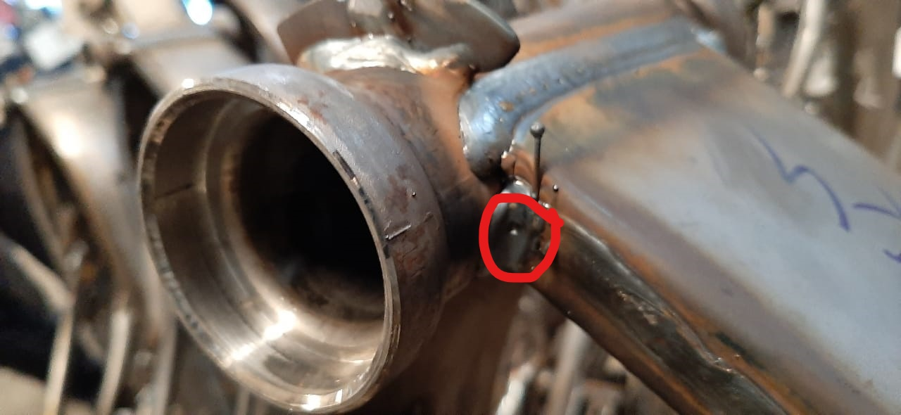

**Fig.1.1** Defect showing burn hole

## **Objective of The Project**

* + - To design a fixture for grinding of frame for accurate grinding of profile on frame so it can be welded properly on head pipe.
    - To hold and locate the work properly so that the prescribed operation can be performed properly and accurately.
    - To reduce the effect or cause of burn holes caused during to grinding of profile on right hand side of k4 frame by means of manual grinding.

# 2. LITERATURE REVIEW

## **2.1. Review of the papers**

**Uday C. Agashe, Adwait Ranpis, Mayur Mahajan, Anil Shriram,** “**Study of Fixture and its Modifications**”

The importance of fixtures and this paper gives detailed information about modifications done in the fixtures up to now. fixtures are widely used in many manufacturing industries. Fixtures are an essential element of the machining system, being part of the precision path and force flux between process and machine tool.

A fixture is a work holding or support device used in manufacturing industry. Fixture is used to securely locate (position in a specific location or orientation) and support the work, ensuring that all parts produced using the fixture will maintain conformity and Interchange ability.

* It should increase the productivity.
* To reduces the production cost.
* To assure the high accuracy of the part.
* The locating and supporting surfaces as far as possible should be replaceable, should be standardized so that their interchangeable manufacture is possible.
* The design should assure the perfect safety of the operator.
* To enable heavy and complex shaped parts to be by holding rigidly to a machine.
* To reduce the production cycle time. [4]

**Berend Denkena, Thilo Grove, Vino suntharakumaran, “Porous metal bonds increase the resourse efficiency for profile grinding”.**

Profile grinding is irreplaceable for the machining of various brittle and hard workpieces, e.g. cutting tools for milling and drilling, seal components made of ceramics and bearing components. Grinding is rather inefficient regarding the energy demand for the machining of

one volume element of material compared to other manufacturing processes. However, the process forces can be reduced without influencing the tool wear by using grinding wheels with a porous metal bond and grains that tend to splinter. This allows higher material removal rates without increasing the process forces, ultimately reducing the energy consumption per workpiece manufactured.

In terms of the necessary energy for machining one volume element grinding is inefficient compared to other manufacturing processes. Compared to hard milling or hard turning, up to 200% more energy is required during grinding. At the same time grinding is irreplaceable for machining various primarily brittle materials such as cemented carbide or ceramic materials. Especially the profile grinding process is of great importance for the stated applications. Cutting tools such as milling tools or twist drills, ceramic sealing components and bearing components or components made of quartz glass for the semiconductor industry are also processed by profile grinding. Basically, the following two principal approaches are applicable in order to improve the energy efficiency of the manufacturing process. [6]

**Michal Yu Wang, Emerald Publication, “Tolerance Analysis For Fixture Layout Design”.**

Localization accuracy is a key concern in the design of a fixture to specify a locating scheme and tolerance allocation. This paper presents an analysis describing the impact of localization source errors on the potential datum-related geometric errors of machined features. The analysis reveals the error sensitivity and error characteristics of critical points of multiple manufacturing features. It shows the importance to consider the overall error among the multiple critical points in Fixture layout design. This paper also suggests an optimal approach to the locator configuration design for reducing geometric variations at the critical points of machined features.

The primary function of a manufacturing fixture is to establish the datum reference frame of the workpiece to be processed with respect to the reference frame of a machine tool. Once the workpiece is fully localized and restrained by the locators and clamp(s) of the fixture, the workpiece is processed to generate geometric features according to a process plan.[8]

**Prof. A. A. Karad, Brijeshwar Wagh, Ajay Shukla, Chetan Gujar, Niladhari Pyata, International Journal of Engineering Research and General Science,** “**A Review on Design Consideration and Need of Fixture in Manufacturing Industries’’**

A fixture is a device for locating, holding and supporting a work piece during a manufacturing operation. Fixtures are essential elements of production processes as they are required in most of the automated manufacturing, inspection, and assembly operations. Fixtures must correctly locate a work piece in a given orientation with respect to a cutting tool or measuring device, or with respect to another component, as for instance in assembly or welding. Such location must be invariant in the sense that the devices must clamp and secure the work piece in that location for the particular processing Operation. Fixtures are normally designed for a definite operation to process a specific work piece and are designed and manufactured individually. The correct relationship and alignment between the components to be assembled must be maintained in the welding fixture. To do this, a fixture is designed and built to hold, support and locate work piece to ensure that each component is joined within the specified limits. A fixture should be securely and rigidly clamp the component against the rest pads and locator upon which the work is done. Fixtures vary in design from relatively simple tools to expensive, complicated devices. Fixtures also help to simplify metalworking operations performed on special equipment’s. Fixtures play an important role on reducing production cycle time and ensuring production quality, by proper locating and balanced clamping methods. Therefore to reduce production cost, fixture design, fabrication and its testing is critic.[7]

**H Radhwan, M S M Effendi, Muhamad Farizuan Rosli1, Z Shayfull1, K. N. Nadia, Design and Analysis of Jigs and Fixtures for Manufacturing Process.**

The objectives of this project are to investigate the collected data and analyse the design of jig and fixture to ease work handling. The methodology of research procedures covered on this project consists of collect data, brainstorming and interprets data, design concept, and documentation. The design of jig and fixtures is using Unigraphics NX7.5 software. The data that can be studied include the analysis of Finite Element Analysis (FEA) using CATIA software, the analysis of design ergonomic, the time study analysis and cost analysis. At the end of this project, this research will be able to give understanding about jig and fixture, design by using Unigraphics NX7.5 software and finally able to do the analysis for the selected part of product by using FEA and other relevant analysis.

Over the past century, manufacturing sectors play an important role to the economic development of a country. Jigs and Fixtures are devices that used to facilitate production work in industry especially that involve in machine. The perfect jigs and fixtures can work repeatability and interchangeability to produce the same parts in production. In manufacturing industry, jigs and fixtures are most important device that can assist the workers in their production process become easier. Jig and fixture is important tool using in industry. Tool that are carries the main forces will form the final shape of the workpiece. The difference between jig and fixture is in the way of the tool is guided with the workpart. Fixture are essential element in production operation as it always important in industry such as automated manufacturing, inspection, and assembly operation [3]. One of the principles that can be follow for designing the jig and fixture for this project is as states by Nee et al. [4] The general factors to be considered when designing jig and fixture are shape, material and state of workpart, premachined surface tolerance, type of operations and the machine tools used, workpiece handling, ergonomics and safety considerations. . The design parameter such as maximum deformation, maximum shear stress, number of contact faces, and maximum holding force were presented. It is found that the gripping ability is the important factor that affected to the clamping and holding the workpart perfectly during machining operation. Besides that, as explained which has done a design and finite element analysis of jig and fixtures for the design are very useful for this project methods. In addition, the dimension of design is very important. This statement can be proved by the research which has presented a fixture design system of eccentric shaft for ginning machine. Designer should design a fixture according to dimension required by industry to fulfil production target. The important consideration that taken when designing this jig and fixture before making any decision also gathered from the research study, product design and development requires that engineers consider trade-offs between product attributes for the cost, weight manufacturability, quality and performance. The optimum design is the usually one that compromise are acceptable, but understanding the impact of design decision on all relevant attributes is difficult. On the journal titles an advance method of jig and fixtures planning by using CAD methods, it reviews methods and techniques for the geometry analysis of fixture feasibility in product development which the synthesis methods including geometrical analysis and fixture assembly planning are surveyed. The decision making for selection of material used is based on the reviewed research, states that a jig and fixture are made from a variety of materials. Some of which can be hardened to resist wear. It is sometimes necessary to use nonferrous metals like phosphor bronze to reduce wear of the mating parts or nylon or fibre to prevent damage to the workpiece. [2]

**Yuwen Sun, Jun Wang, Dongming Guo, Qiang Zhang, ‘Modeling and numerical simulation for the machining of helical surface profiles on cutting tools.**

The classical conjugation and envelope method is very accurate and effective for forward and inverse calculations of grinding helical surfaces. However, this method involves complicated mathematics and requires that the profiles be continuous. It can also result in undercutting or interference to the desired surface profiles. In this paper, a new approach is proposed to simulate the grinding process of helical surfaces on cutting tools. The paper begins with the reconstruction of cutter helicoids from sampled points. Using the recovered helical parameters from the sample points, the cross-sectional profile of the cutter surface is derived using a polynomial curve. A numerical method for calculating the profile of the grinding wheel required for the cutter surface profile is then provided. Finally, an optimization method is presented for solving the problem of inverse calculation to determine the helical surface profile for a given grinding wheel profile and setting parameters. The feasibility of the approach is tested by simulation results, which shows that the proposed approach can eliminate undesired tool-work interferences and undercutting.[3]

**Djordje Vukelic, Branko Tadic, Ognjan Luzanin, Igor Budak, Peter Krizan3 and Janko Hodolic, A rule-based system for fixture design**

Modern market imposes stringent demands regarding the product quality/price ratio, with an ever-decreasing time-to-market. Furthermore, products are increasingly manufactured in small batches and high varieties, which requires flexibility not only from manufacturing system but the entire manufacturing process. Such demands require manufacturing systems which are highly automated in the domain of preparation and realization of manufacturing activities, which include fixture design. Owing to present trends towards reduction of lead time and human effort devoted to fixture design, computer aided fixture design has gained a prominent role in computer aided environment. In this paper, a system for computer-aided fixture design is presented and verified. This system comprises methods and techniques for fixture design. The structure of this system is based on modular principle, and uses data base and knowledge base. The system allows fixtures to be designed based on geometric features of workpiece, process planning and machining information. A segment of output results is also shown. Finally, conclusions are presented with directions for future investigation.[5]

**Hendrikus Johannes Josephus Megens, Emmasingel, Eind hoven, Method of Manufacturing A Profiled Grinding Wheel.**

A method of manufacturing a profiled grinding wheel in which a grinding band is provided on the profiled circumference of a supporting disc, the band being built up from a synthetic binder and diamond grains. Starting material is a ceramic grinding wheel which, after profiling, is used for grinding a counter profile in a mould. By reducing the diameter of the supporting disc, a gap is formed between the circumference of said disc and the counter profile in the mould, the height of said gap being equal to the thickness of the grinding band to be provided. A mix ture of synthetic binder and diamond grains is provided on the circumference of the supporting disc. By rotating the supporting disc in the counter profile, said mixture is distributed across the gap and a grinding band of constant thickness is formed. All operations are carried out with the same fixture of the supporting disc and the mould.[9]

**Ricky, Abrasive grinding defects hazards related to abrasive grinding wheel.**

As we know from the study of the process of abrasive grinding that it is basically a process of metal removal through abrasive action. Needless to say, such a procedure would surely result in the production of sufficient quantities of heat. Hence it is very important to study the effect of heat during the grinding process in order to have an idea of the thermal effects involved. These effects can be studied from two perspectives – the effect on the grinding wheel and the effect on the work piece itself. Apart from heat there are other types of defects as well which could arise during the process of grinding. All these have been dealt with in the sections below.

* Defects in Grinding

We will first study the thermal effects of grinding and these can be covered under two headings namely effects of the wheel and that on the work piece respectively as shown below.

* Grinding wheel thermal effects

The main effect of heat on the grinding wheel is the development of the cracks known as grinding cracks. These cracks appear in a direction that is at right angles to the grinding marks. Obviously if these cracks are present in too large a number, the grinding wheel would need to be replaced.

* Work piece thermal effects

The work piece is more affected by the heat mainly because it retains a larger proportion of the heat generated during the grinding operation. The work piece can get damaged in various ways including some or all of the following. There could be certain reactions which take place at the high temperatures attained during grinding. These reactions could result in minor changes such as discolorations of the surface due to oxide production, or there could be more serious chemical damage to the work piece. The material properties of the work piece might change due to the application of sudden heat during the process. The material could become brittle or it could get scratched due to ultra-sharp abrasive material. One of the solutions if the work piece is getting overheated is to change the grinding wheel with another wheel which is made up of relatively softer material.

* Other Problems and safety measures

Apart from thermal heating there are several other problems which may arise during the process of grinding. For example, the grinding wheel might be wearing too soon and this can be rectified through the use of harder wheel so that its relative hardness is much more compared to the work piece.[1]

**Books**

**Design of Jigs, Fixtures and Press Tools, K. Venkataraman**

To achieve the desired quality and quantity of production, the concept of accuracy and interchangeability go hand in hand. They play a major role in meeting the present-day classes of engineering production, namely, “flow production” and “batch production”. To necessitate the need of jigs, fixtures and special tools, the four main engineering classes of production are as follows:

1. **Job Production**: This involves the manufacture of specialized components or systems to meet the specific needs of the customers. Examples of job production are the manufacture of jigs, fixtures and press tools.
2. **Batch Production**: Some of the examples of batch production are the manufacture of airplanes, aero-engines, battle tanks, etc., that use the concept of intermittent manufacture of large range of products, produced in batches. Some brands of motorcars like “Benz” and “BMW” may be classified under “batch production” as they are required to meet specific requirements.
3. **Flow Production**: In flow production, the standardised finished products are produced in plants, specifically laid out for this purpose. Examples of flow production are the modern motorcar plants.
4. **Mass Production**: In this type of plants, the products are produced in mass quantities by specialized and repetitive methods, without requiring specialized layouts as in the case of flow production. Examples are mass production of screws, pins, hand tools, like chisels, spanners, hammers, etc.

## **Discussion on Research Papers**

* + 1. **Degrees of freedom**

The degree of freedom (DOF) of a [mechanical system](https://en.wikipedia.org/wiki/Mechanical_system) is the number of independent parameters that define its configuration. It is the number of parameters that determine the state of a physical system and is important to the analysis of systems of bodies in [mechanical engineering](https://en.wikipedia.org/wiki/Mechanical_engineering), [aeronautical engineering](https://en.wikipedia.org/wiki/Aerospace_engineering), [robotics](https://en.wikipedia.org/wiki/Robotics), and [structural engineering](https://en.wikipedia.org/wiki/Structural_engineering). The position and [orientation](https://en.wikipedia.org/wiki/Orientation_(geometry)) of a rigid body in space is defined by three components of [translation](https://en.wikipedia.org/wiki/Translation_(physics)) and three components of [rotation](https://en.wikipedia.org/wiki/Rotation), which means that it has six degrees of freedom:

* + - 1. Moving up and down
      2. Moving left and right
      3. Moving forward and backward
      4. Swivels left and right
      5. Tilts forward and backward
      6. Pivots side to side.
    1. **3-2-1 Principle of Location**

In 321 principle, the (usually a plane) locks 3 degree of freedom 2 rotations and 1 translation respectively. The secondary locks another 2 degree of freedom, 1 translation and 1 rotation. Finally the tertiary datum locks the final translation. In 321 all datums are mutually perpendicular to each other.[4]

* + 1. **Locating Principles**

Introduction**:** One of the principal purposes of a machining fixture is to locate the workpiece surfaces for performing a machining operation. This is usually done with respect to a number of factors to be considered such as the reference datum, supporting surfaces, features that are likely to obstruct the tool movement or access direction, etc. In general, the following surfaces should be distinguished:

Active surfaces -These are surfaces to be machined, i.e. surfaces which are subjected to the action of cutting tools.

Supporting and locating surfaces -These are surfaces by means of which the workpiece is to be located with respect to set-to-size cutting tools.

Clamping surfaces -Clamping surfaces are subjected to the clamping forces for obtaining invariant location. Clamping surfaces are usually not finish-machined surfaces as clamping marks could damage the finish.

Datum surfaces -Datum surfaces are reference surfaces where the dimensions are to be maintained and measured.

Free surfaces -Free surfaces are surfaces not involved in the set-up for the particular machining operation.

* + 1. **Restrictions on the Degrees of Freedom of a Workpiece**

A workpiece, just like any free solid body, has six degrees of freedom (some researchers have referred this to the twelve degrees of freedom by considering the

+I- movements in each category):

* Three rectilinear displacements along the mutually orthogonal co-ordinate axe
* Three angular displacements with respect to the same axes.

During a set-up, it is necessary to restrict certain degrees of freedom so as to locate and orient the active surfaces with respect to the cutting tools. Since supporting or restricting surfaces may vary from the true geometrical shape, especially on rough- machined surfaces or cast blanks, it is desirable that the workpiece be located with respect to the point supports. Locating using point supports in the form of hemi- spherical rest buttons would considerably reduce the influence of geometrical

variations of locating surfaces on the locating accuracy. For prismatic parts, the general principle of 3-2-1 location is most commonly employed. For achieving greatest stability, the first three points of location on the primary surface should be as far apart as possible, or the area enclosed by the three points as large as possible. For larger cast workpieces, the 3-2-1 locating principle is frequently used. Since this violates the locating constraints, one of the locating points would need to be an adjustable one. However, it is also a good practice for larger castings to be designed with accurate fixturing points. These points are subsequently removed after the first few surfaces have been machined. For cylindrical workpieces, three-point location cannot be obtained because of the non-existence of plane surfaces, V-locators and close-fitting bushes are often used instead. For circular laminae, location can be achieved with the aid of a slot- support. When a workpiece is required to be located with respect to an inside hole or bore, a plug is used for locating the workpiece. Locating from two holes typically uses a full and a diamond plug combination, with the latter inserted in the larger of the two holes. The details of the principles of location can be easily found in general texts on fixture design (Henriksen, 1973) and will not be repeated here.

* + 1. **Clamping Principles**

Introduction: In every machining operation, clamping of workpieces is an essential requirement. A clamp can be defined as a device for providing an invariant location with respect to an external loading system. In other words, the process of clamping induces a locking effect which, through frictional or some other forms of mechanism, provides a stability of location which cannot be changed until and unless external loading is able to overcome the locking effect. Hence, when a cutting force is producing a load or moment on the workpiece, it is necessary that a sufficient clamping force must be exerted to withstand such actions. The creation and retention of locking effect against external loads are the principal objectives of any locking devices.

* + 1. **Basic Principles of Clamping**
* **Orientation of Locators and Clamping Force**

It is necessary in all clamping devices that the clamping forces hold the workpiece in its located position and should not cause any positional displacement or excessive distortion under the action of the clamping forces. Clamping forces should be directed towards supporting and locating elements on overhanging or thin sections of the workpiece. In addition, the force should be transmitted to the rigid sections of the body frame of the fixture. Cylindrical workpieces located in V-blocks can be clamped using another V- block, making a 4-point clamping, or clamped in a 3-jaw chuck, in a 3-point clamping configuration. The latter is usually more common, especially in turning operations.

* **Effect of External Forces on the Clamping Action**

Clamping elements can be classified in accordance with their force-deflection characteristics. There are two broad sub-divisions, which is:

* Type I: clamping elements in which the elastic deformation increases with clamping force, such as screws, levers, cams, etc.,
* Type II: clamping elements in which the clamping force assumes a constant value independent of the elastic deformation at the contact surfaces such as fixtures operated with hydraulic or pneumatic pressure Within the elastic region, clamping elements based on elastic deformation, i.e. Type I clamps, would exhibit a linearly increasing clamping force in proportion to the deformation of thec lamping element, if the workpiece or the locator is assumed to be rigid. If the workpiece or locator deforms, it will cause a relaxation of the clamping element and the clamping force will decrease. A limiting case arises when the clamping is lost and the force becomes zero. In Type II clamps, the clamping force remains constant at pre-set values and is independent of workpiece and locator deformation. This type of clamping device is therefore more reliable and would not relax over time.
  + 1. **Types of Clamps**

Clamping elements may be either manually operated or actuated by pneumatic, hydraulic or a combination of other power facilities. They are also classified according to the mechanism by which a mechanical advantage is attained. The two basic classes include:

* Application of inclined plane theory, i.e. wedges, screws, cams, etc.,
* Application of lever principle, i.e. levers, toggles, etc.

Manual clamping of workpieces has the following disadvantages:

* Each workpiece is clamped with varying force,
* It is difficult to determine the required force for reliable clamping,
* Fatigue of operator due to manual clamping takes place,
* Time required to actuate manual clamping is longer compared to power- actuated clamping,
* Comparatively small amount of force is available without large force amplification device.

## **Research Gap**

* + - Profile grinding is a though job to perform and many researches are made on profile grinding on objects.
    - According to research paper for proper grinding convenient fixture is required.

Due to manual grinding on the workpiece the grinding was improper so to eliminated the problem a proper grinding fixture is design.

# SYSTEM DESIGN

In order to develop the fixture for grinding the design of system is done in which the design of fixture body, clamping device and locators which are to be used in the system are discuses below.

## **Component or Work Piece**

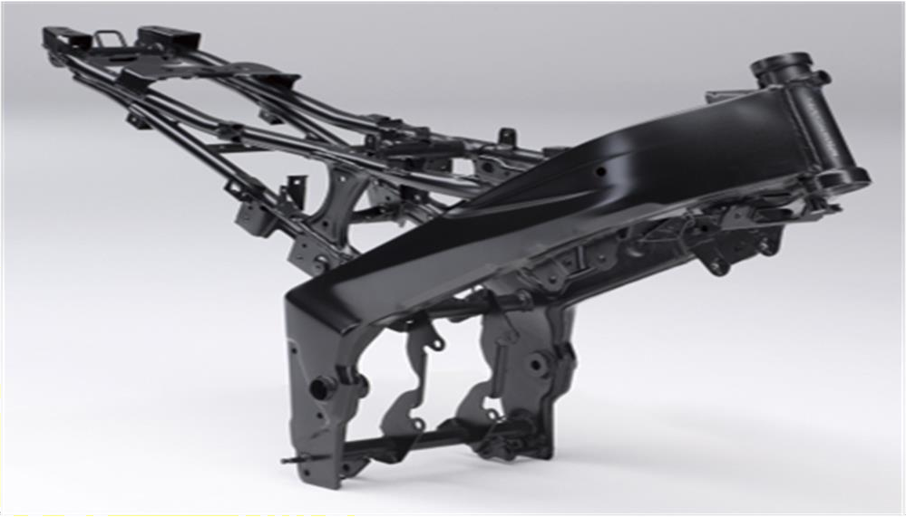**Fig.3.1.** Final product of the industry consisting of LHS and RHS stamp (K4 Frame).

The above figure shows the assembled chassis of Bajaj Pulser NS200 which is also termed as K4 frame in the industry. The two solid parts in front are stamps and other system is supporting system on which all parts are assembled.

The actual view of the side stamp is show in fig which get connected to the head cylinder in the skeleton of the Bajaj pulsar.

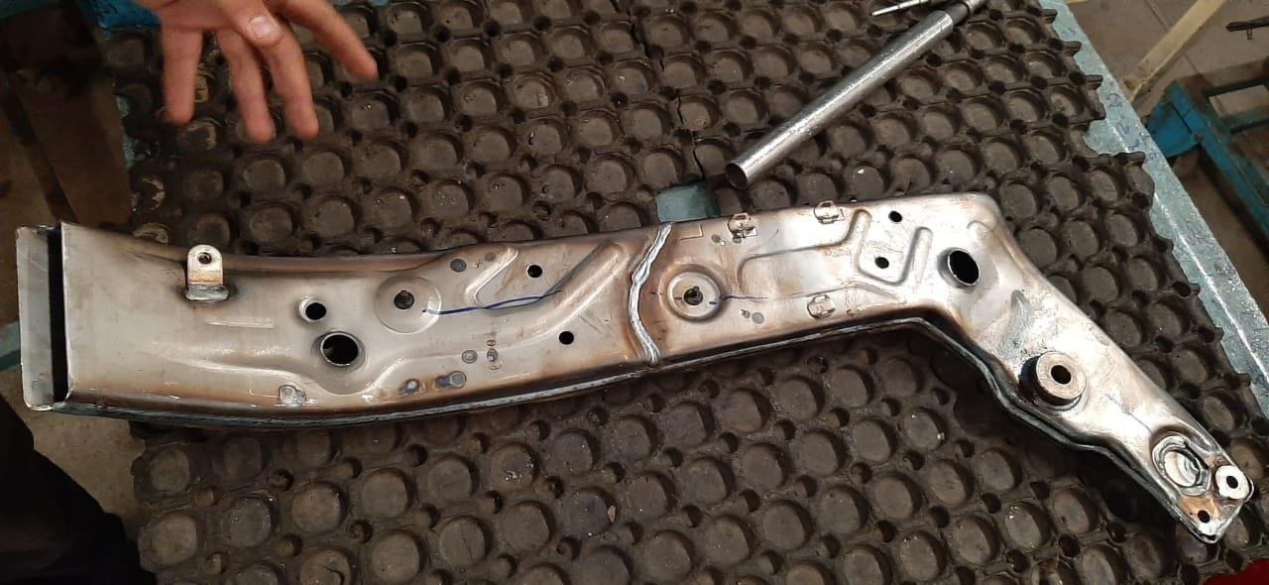

**Fig.3.2**. Stamp for which fixture has to be designed for its proper holding

## **Procedure**

* Fixture design consists of a number of distinct activities: fixture planning, fixture layout design, fixture element design, tool body design, etc. They are listed in their natural sequence, although they may be developed in parallel and not necessarily as a series of isolated activities in actual execution. Fixture design deals with the establishment of the basic fixture concepts:
* Fixture layout is an embodiment of the concepts in the form of a spatial configuration of the fixture, Fixture element design is concerned with the concrete details of the locators, clamps and supports, Tool body design produces

## **Components of Fixture**

Generally, all fixtures consist of the following elements:

* Locators-locator is usually a fixed component of a fixture. It is used to establish and maintain the position of a part in the fixture by constraining the movement of the part. For workpieces of greater variability in shapes and surface conditions, a locator can also be adjustable.
* Clamps-A clamp is a force-actuating mechanism of a fixture. The forces exerted by the clamps hold a part securely in the fixture against all other external forces.
* Supports-A support is a fixed or adjustable element of a fixture. When severe part displacement/deflection is expected under the action of imposed clamping and processing forces, supports are added and placed below the workpiece so as to prevent or constrain deformation. Supports in excess of what is required for the determination of the location of the part should be compatible with the locators and clamps.
* Fixture Body-Fixture body, or tool body, is the major structural element of a fixture. It maintains the spatial relationship between the fixturing elements mentioned above, which is, locators, clamps, supports, and the machine tool on which the part is to be processed. A structure combining the fixture elements in the desired spatial relationship with the machine tool
* Fixture planning is to conceptualize a basic fixture configuration through analyzing all the available information regarding the material and geometry of the workpiece, operations required, processing equipment for the operations, and the operator. The following outputs are included in the fixture plan:
  + Fixture type and complexity
  + Number of workpieces per fixture
  + Orientation of workpiece within fixture
  + Locating datum faces
  + Clamping surfaces
  + Support surfaces, if any
  + Fixture element design is either to detail the design drawings committed on paper or to create the solid models in a CAD system of the practical embodiment of the conceptual locators, clamps and supports. It is possible to use standard designs or proprietary components. The following outputs are included in the fixture element design:
  + Detailed design of locators
  + Detailed design of clamps
  + Detailed design of supports
* The following design criteria must be observed during the procedure of fixture design:
* Design specifications
* Factory standards
* Ease of use and safety Economy

## **CAD Modelling**

**Fig 3.3.** 3-D Model Catia design of component

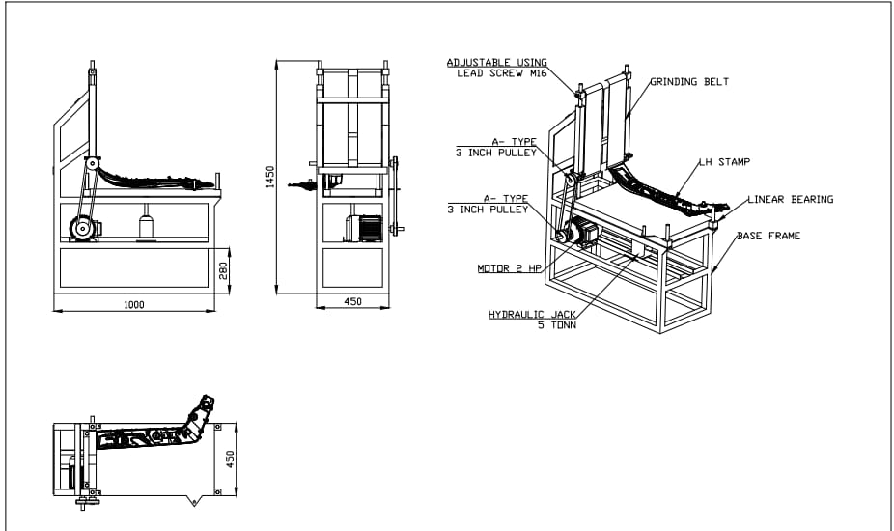

**Fig 3.4.** Drafting of Design.

In order to understand the visualization concept of fixture in 3D the modeling of the fixture is done and also to fix the position of supporters and locators in the design of fixture.

# SYSTEM MANUFACTURING

## **Components and their specification**

* Base Table and Base Plate

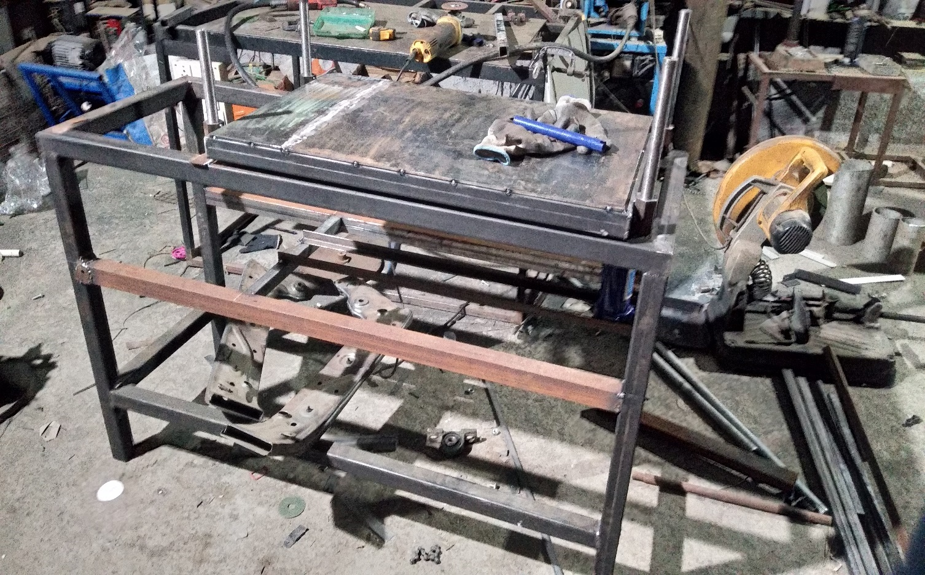

**Fig 4.1**. Base table and plate

Specification:

Base table

Material-Low Carbon Steel

Dimensions-1000*450*450

* Clamp

Toggle clamp

Quantity-2 nos.

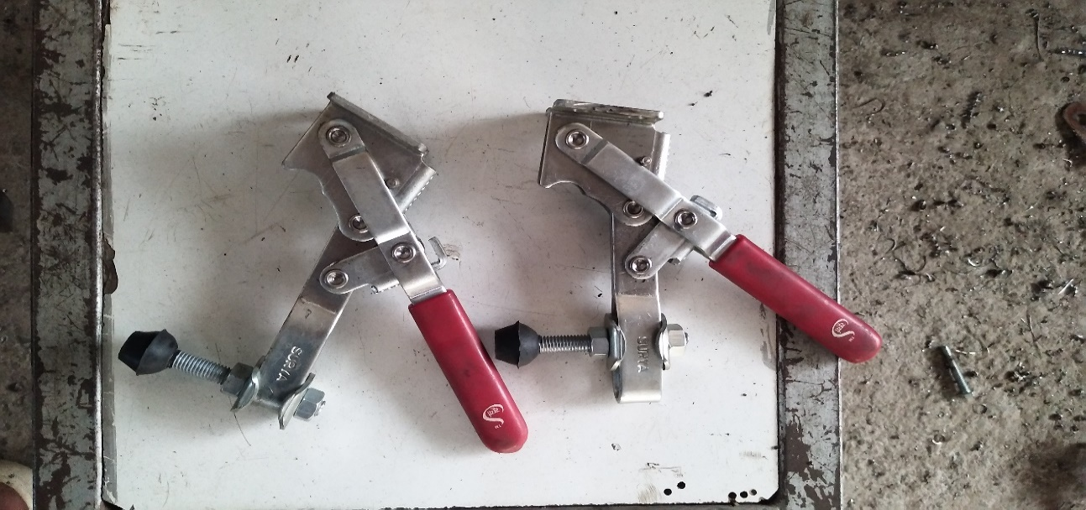

**Fig 4.2**. Toggle clamps.

* Rollers/pulleys

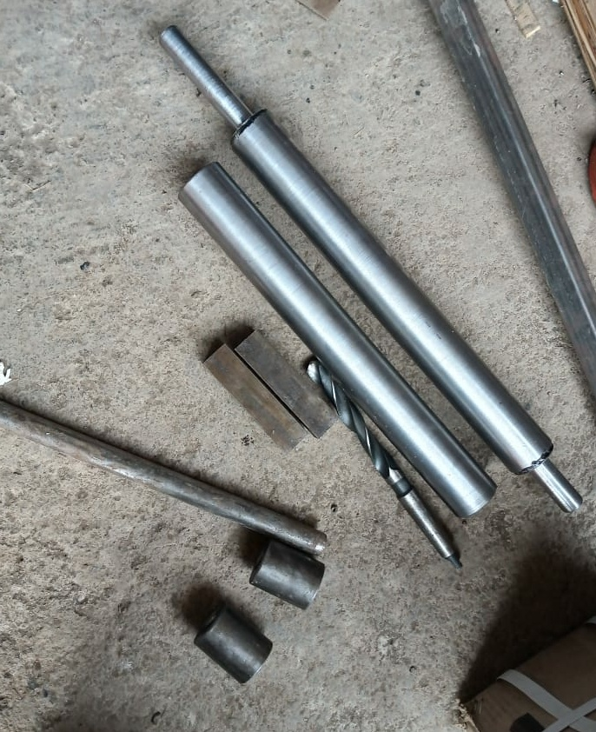

**Fig 4.3.** Roller pulleys

Specification:

Material-mild Steel

Dimensions-Grinding Roller dia.-33.5mm (30-35mm feasible)

Length-300mm

* Hydraulic jack

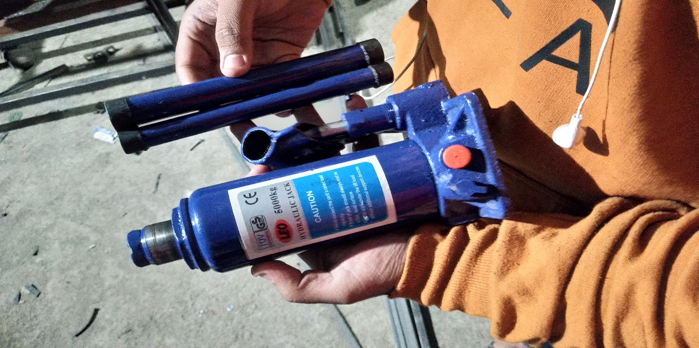

**Fig 4.4**. Hydraulic jack (Actuator)

Specification:

Stroke Length- 120mm

* Motor

Specification:

Power-2 HP

Speed-1440rpm

Rating-180-220V Three phase motor

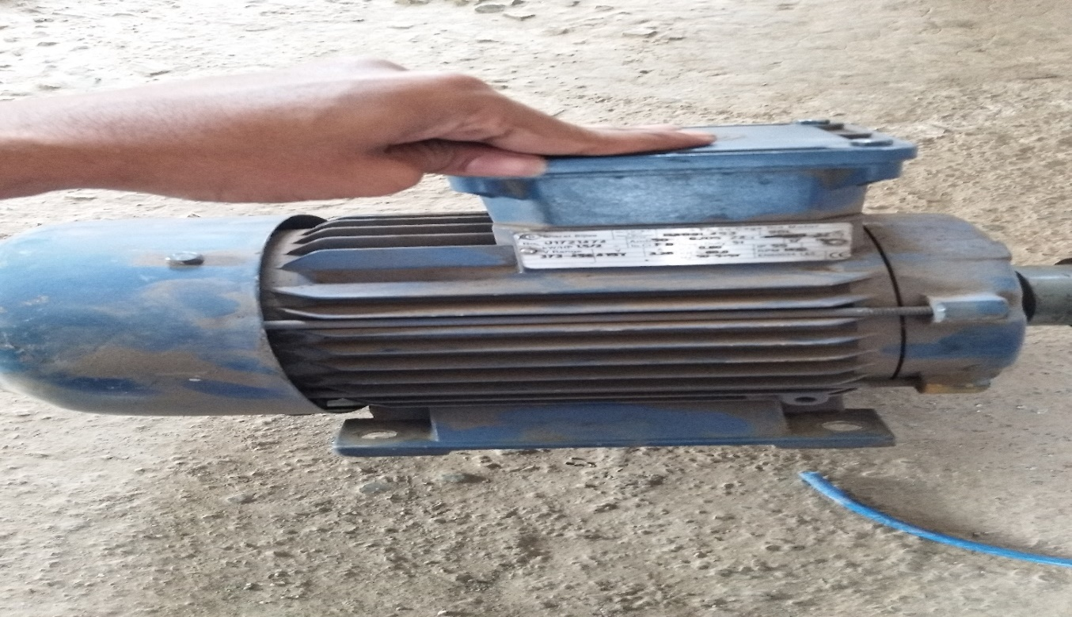

**Fig 4.5**. Motor (3 ph.)

* Abrasive Paper

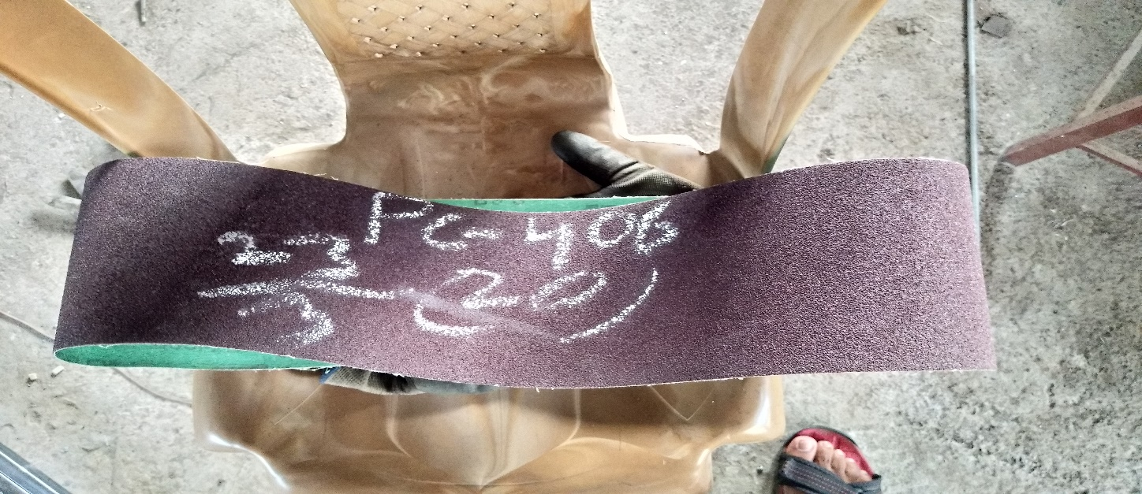

**Fig** **4.6**. Abrasive Grinding paper

Specification:

Rough grinding paper

Grade- 80

* 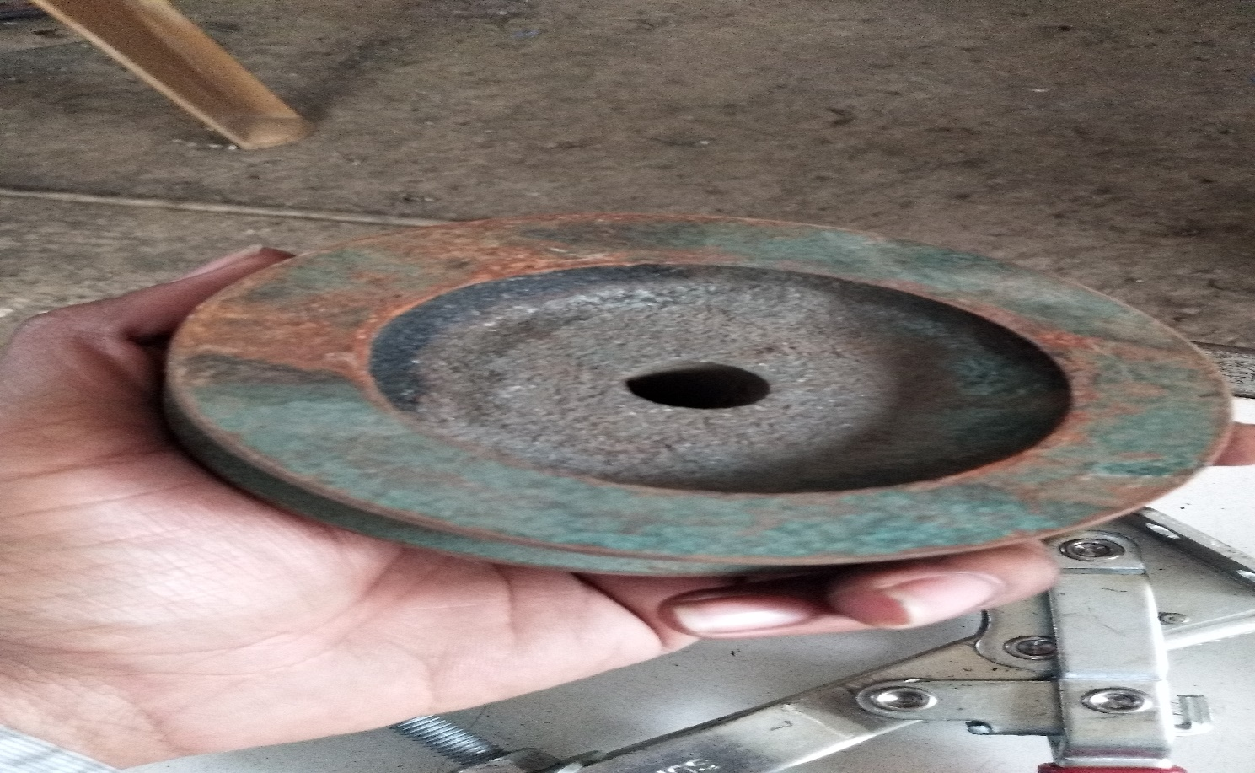Motor Pulley

**Fig 4.7**. Motor Pulley

Specification:

Diameter- 75 mm

# EXPERIMENTAL VALIDATION

## **Experimental Testing and Observation**

In the experiment performed by us on the stamp the depth of grinding profile required was roughly 2mmand depth achieved by our machining was roughly 1.5 mm. By further accuracy and adjustments in the machining system we can achieve the desired profile accurately.

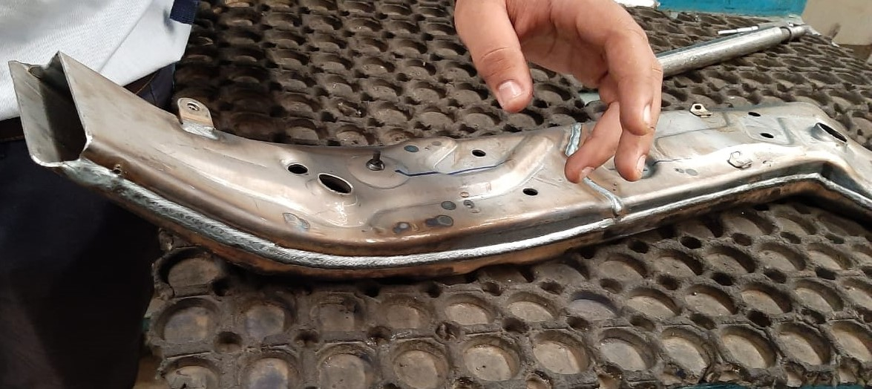

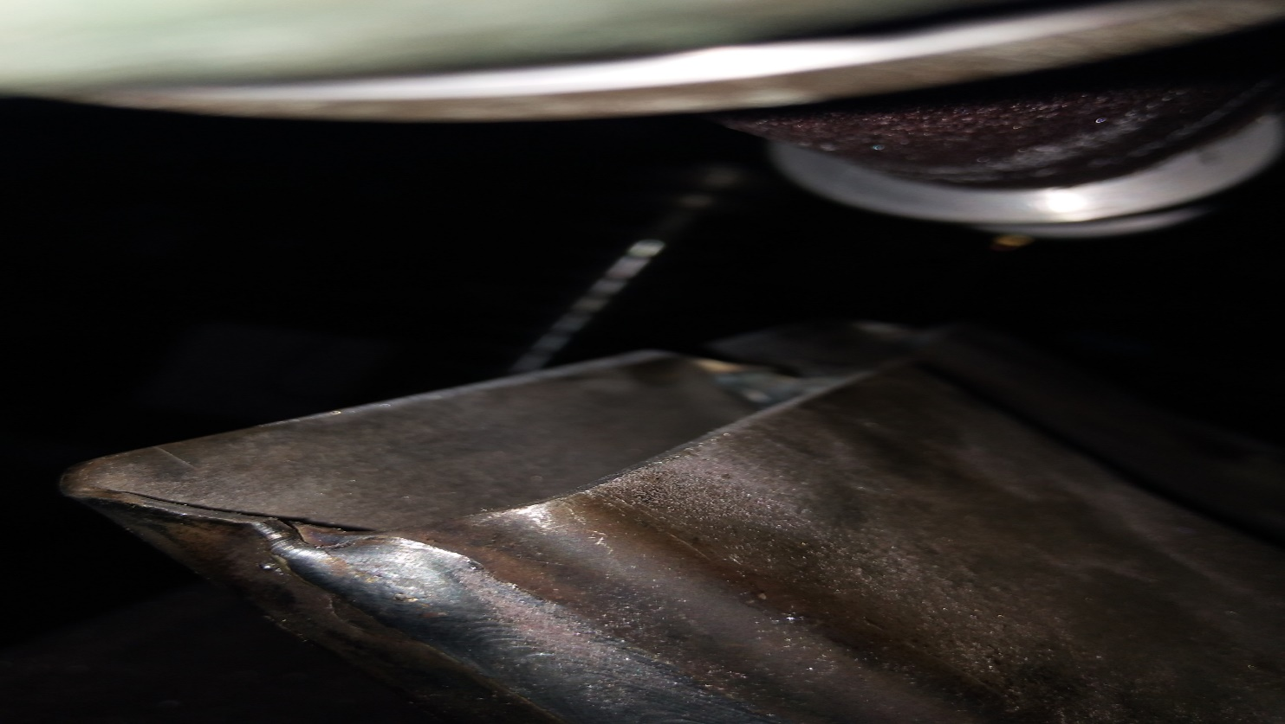**Fig 5.1**. Stamp machined by industrial worker

**Fig 5.2**. Stamp machined on our grinding fixture

## **Calculation**

Metal Removal Rate (MRR)

MRR=V*B*H

Where

V=Feed rate (mm/s) = 10 mm/s

B=Width (mm) = 1 mm

H=Depth of Cut (mm)= 2 mm

Therefore

MRR=10*1*2

MRR=20 mm3/s

# GRAPHS AND RESULTS

## **Graphical Comparison**

Line graph showing grinding time requirement of the stamps. The graph is plot against the tested component on X axis to time on Y axis.

**Graph 1**. Grinding time of LHS and RHS stamp

Line graph after profile grinding fixture

Line graph of grinding done on profile grinding fixture.

**Graph 2**. Combined grinding time on fixture

**Analysis**

|  |  |  |  |  |  |
| --- | --- | --- | --- | --- | --- |
| **Sr. No.** | **Inspected Unit(14/08/2019)** | **Inspected Unit(16/08/2019)** | **Inspected unit(23/08/2019)** | **Inspected Unit(11/09/2019)** | **Inspected unit(14/09/2019)** |
| 1 | Burn Hole | Burn Hole | OK | Burn Hole | OK |
| 2 | OK | OK | OK | Burn Hole | OK |
| 3 | Burn Hole | Burn Hole | OK | OK | Burn Hole(R.H.S.) |
| 4 | Burn Hole | Ok | OK | Burn Hole | OK |
| 5 | Burn Hole | OK | OK | Burn Hole | OK |
| 6 | OK | Burn Hole | Burn Hole | Burn Hole | Burn  Hole(L.H.S.) |
| 7 | Burn Hole | OK | OK | Burn Hole | OK |
| 8 | Burn Hole | OK | OK | OK | OK |
| 9 | Burn Hole | OK | OK | Burn Hole | OK |
| 10 | Burn Hole | Burn Hole | Burn Hole | Burn Hole | OK |

**Table 1**. Analysis

## **Result**

Before

|  |  |
| --- | --- |
| **PARAMETER** | **EFFECT** |
| Productivity | Affected due to presence of burn hole but increased after rework |
| Quality | Quality produced is good but affected slightly due to the defect |
| Cost | Cost required is more since the product has to be reworked |

**Table 2.** Results when machined manually

After

|  |  |
| --- | --- |
| PARAMETER | EFFECT |
| Productivity | Increased since both stamps can be grinded in single operation with accuracy |
| Quality | Quality produced is good and chances of defects reduced |
| Cost | Cost is reduced since no reworking is required |

**Table 3**. Results when machined on fixture

# SUMMARY

* In this project we studied and analyzed the manufacturing of side stamp and also the associated defect of the stamp while manufacturing and time and cost west on such defective stamp in reworking.
* We also find the different way to overcome the defect with minimum time and cost such as to reduce the cost and time of rework.
* Our aim was to develop a fixture for the given component for the operation to be performed precisely.
* We studied different type of fixture and developed the fixture for our component for its precise locating and holding and we came across different problems face during fixture design.

# CONCLUDING REMARKS

## **Conclusion**

Fixture is the manufacturing tool that is employed to reduce interchangeable and identical components. It is unique work holding device designed specifically for machining and assembly. The paper explained that since the design of fixture is dependent on numerous factors and design consideration of fixture. From the study we can conclude that there are different steps and approaches are available for designing the fixture. The fixture in manufacturing industries is very useful that reduces the worker fatigue and provides higher degree of freedom of operator safety by reducing the concentration and efforts required to hold the work piece.

## **Future Scope**

Modern market imposes stringent demands regarding the product quality/price ratio, with an ever-decreasing time-to-market. Furthermore, products are increasingly manufactured in small batches and high varieties, which requires flexibility not only from manufacturing system but the entire manufacturing process. Such demands require manufacturing systems which are highly automated in the domain of preparation and realization of manufacturing activities, which include fixture design. Owing to present trends towards reduction of lead time and human effort devoted to fixture design, computer aided fixture design has gained a prominent role in computer aided environment.

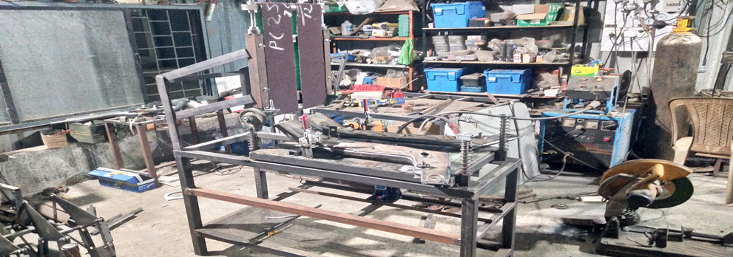

**Fig 8.1**. Grinding fixture setup

Some machining operations are so simple which are done quite easily, such as turning the job is held in position in the chuck and turning operation is done easily. No other device is used to hold the job or to guide the tool on the machine in such an operation. But some operation are such type in which the tool is required to be guide by means of another device and also some jobs are of such forms which guides the tool is jig and the device which hold the job in position is called fixture. It serves that to reduce working time by allowing quick set up and smoothing the transition from part to part. It frequently reduces the complexity of a process, allowing for unskilled workers to perform it and effectively transferring the skill of the tool maker to the unskilled worker. It also allows for higher degree of freedom of operator safety by reducing the concentration and effort required to hold a piece steady. Economically speaking the most valuable function of a fixture is to reduce labour cost by eliminating one of the operators instead of two or three, by securing the work piece.

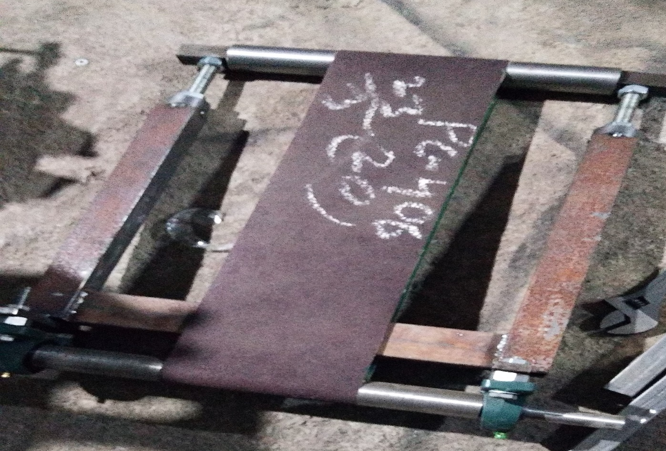

**Fig 8.2.** Results when machined on fixture



**Fig 8.3**. Grinding Rollers

The rollers used in the above machine are made of mild steel and are specially designed for particular task. The rollers can be customized according to the requirement of the operation.

The diameters of the rollers can be varied according to the requirement hence the machine can be used for profile grinding of ani diameter as per the requirement. There is a separate arrangement for removal of rollers and the required diameter rollers can be installed.

# REFERENCES

1. 'Abrasive grinding defects hazards related to abrasive grinding wheel'. ‘Bring hub engineering article’.
2. ‘Design and Analysis of Jigs and Fixtures for Manufacturing Process’, ‘IOP Conf. Series: Materials Science and Engineering551 (2019) 012028’, by H Radhwan, M S M Effendi, Muhamad Farizuan Rosli1, Z Shayfull1, K. N. Nadia.
3. ‘Modeling and numerical simulation for the machining of helical surface profiles on cutting tools’, ‘International Journal of Advanced Manufacturing Technology (2008) 36:525–534’, by Yuwen Sun & Jun Wang & Dongming Guo & Qiang Zhang.
4. ‘Study of Fixture and its Modification’, ‘International Journal for Research in Applied Science & Engineering technology’, by Prof. Mr. Uday C. Agashe, Mr. Adwait Ranpise, Mr. Mayur Mahajan, Mr. Anil Shrirame.
5. ‘A rule-based system for fixture design’, ‘Scientific Research and Essays Vol. 6(27), pp. 5787-5802, 16 November, 2011’, by Djordje Vukelic, Branko Tadic, Ognjan Luzanin, Igor Budak, Peter Krizan3 and Janko Hodolic.
6. ‘Porous metal bonds increase the resource efficiency for profile grinding’, ‘25th CIRP Life Cycle Engineering (LCE) Conference, 30 April ± 2 May 2018, Copenhagen, Denmark’, by Berend Denkena, Thilo Grove, Vino Suntharakumaran.
7. ‘A Review on Design Consideration and Need of Fixture in Manufacturing Industries’, ‘International Journal of Engineering Research and General Science Volume 4’, by Prof. A. A. Karad, Brijeshwar Wagh, Ajay Shukla, Chetan Gujar, Niladhari Pyata.
8. ‘Tolerance analysis for fixture layout design’, ‘Research article’ Department of Automation and Computer-Aided Engineering, by Michael Yu Wang.
9. ‘Method of Manufacturing A Profiled Grinding Wheel’, ‘United States Patent Office’ by Hendrikus Johannes Josephus Megens, Emmasingel, Eind hoven.

* **Books**

1. Design of Jigs, Fixtures and Press Tools, K. Venkataraman